Scenario 1: A software house in England is writing a software for households. The aim of the software is to ensure that the small children that are as young as 15 months or young should never go farther than 100 meters from their parent at any time whether when playing unattended. A feature of the software is such that a child can be registered by the parent in the application. Another feature is that the parent may track the student through a Battery Assisted Passive (BAP) RFID tag the child should be wearing and which is sensed by an Active Reader Active Tag (ARAT) RFID reader the parent should be wearing. The RFID reader should feed the data on temperature, humidity and status of whether an RFID is not visible any more to a Tracking feature which sends out a beep if a child’s RFID tag is out of scope. The Tracker should also make a sound if the child’s body temperature exceeds a normal body temperature.

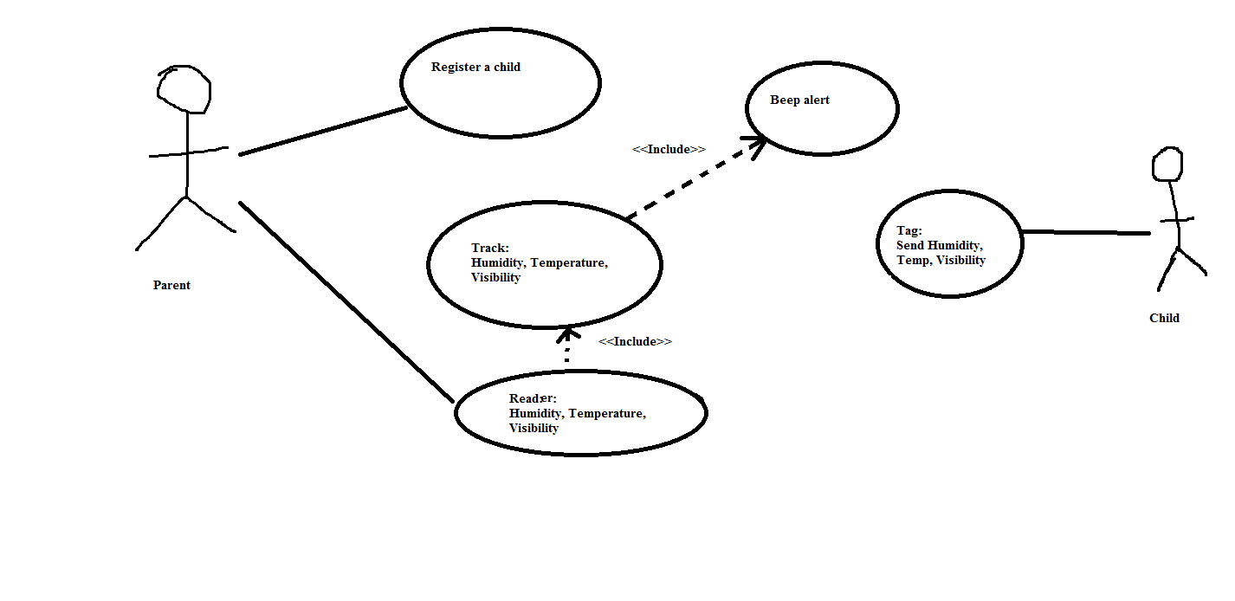

Scenario 2: Do you know that it costs a lot of money to get a ’Certified Java Programmer’ certificate? It could cost you thousands of euros. Let’s imagine we will develop a browser-based training system to help people prepare for such a certification exam. A user can request a quiz for the system. The system picks a set of questions from its database, and compose them together to make a quiz. It rates the user’s answers to make a report, and gives hints if the user requests it. In addition to users, we also have tutors who provide questions and hints. And also examinators who must certify questions to make sure they are not too trivial, and that they are sensical.



Scenario 3: Suppose we want to develop software for an alarm clock. The clock shows the time of day. Using buttons, the user can set the hours and minutes fields individually, and choose between 12 and 24-hour display. It is possible to set one or two alarms. When an alarm fires, it will sound some noise. The user can turn it off, or choose to ’snooze’. If the user does not respond at all, the alarm will turn off itself after 2 minutes. ’Snoozing’ means to turn off the sound, but the alarm will fire again after some minutes of delay. This ’snoozing time’ is pre-adjustable.

